Install Amazon Corretto JDK (Java Development Kit)
Contents
Install Amazon Corretto JDK (Java Development Kit) 1
Install JDK 1
Integrated Development Environment (IDE) 2
Install Visual Studio Code 2
Install Extension Pack for Java 3
Visual Studio Code Inlay Hints 3
Other IDE’s 4

Install JDK
NOTE: Kali Linux and most distributions of Linux already have Java installed.
Before you can compile and run any Java programs, you must download and install the JDK (Java Development Kit).
- Used on Amazon Servers
- James Gosling (inventor of Java) works at Amazon
Amazon Corretto is a no-cost, multiplatform, production-ready distribution of the Open Java Development Kit (OpenJDK). Corretto comes with long-term support that includes performance enhancements and security fixes. Corretto is certified as compatible with the Java SE standard and is used internally at Amazon for many production services.
- Uninstall any JDK’s on your system.
- Download and install the Amazon Corretto Windows 64-bit JDK 21 from
https://corretto.aws/downloads/latest/amazon-corretto-21-x64-windows-jdk.msi
Test to make sure Java is installed. Your version number may be different. We will be using Coretto JDK 21.
- At a command prompt: java -version
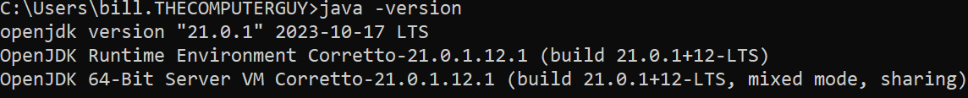

Integrated Development Environment (IDE)
A good IDE (Integrated Development Environment) can help you create good code and can speed up the software engineering process. There are many good Java IDE’s available. Visual Studio Code will be used for most class demonstrations.

Install Visual Studio Code
Microsoft Visual Studio Code is an opensource editor sponsored by Microsoft. Microsoft also sponsors GitHub. Visual Studio Code integrates with GitHub Desktop.
There is extensive information on how to get started with Visual Studio Code on the Visual Studio Code website.
- Go to https://code.visualstudio.com/download.
- Download and install the System Installer 64-bit version of Visual Studio Code for your operating system.
- Double click the downloaded file to start the installation.
- During the installation: Select Additional Tasks select the following items. You can create a desktop icon if you wish.
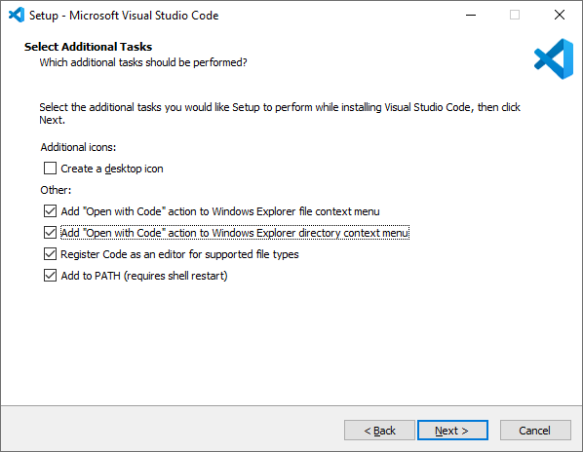

Install Extension Pack for Java
- Launch Visual Studio Code.
- Go to the View menu Extensions command.
- Search for Extension Pack for Java Install it.
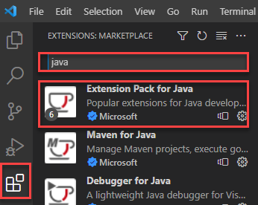

Visual Studio Code Inlay Hints
You might notice some extra characters in your Java code you did not type in. This is called Inlay Hints. You may not want those hints at this time.
- In Visual Studio Code File Preferences Settings.
- Type inlay in the search bar.
- Change the setting to offUnlessPressed as shown.
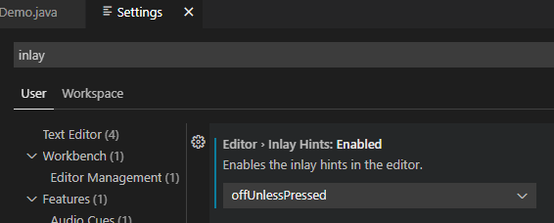

Other IDE’s
At the beginning of your Java journey, it is a good idea to use a simple IDE like Visual Studio Code. You can concentrate more on the code than on learning the interface.
As you grow and gain more experience, you may want to experiment with more complex programming environments like Eclipse or IntelliJ Community.

